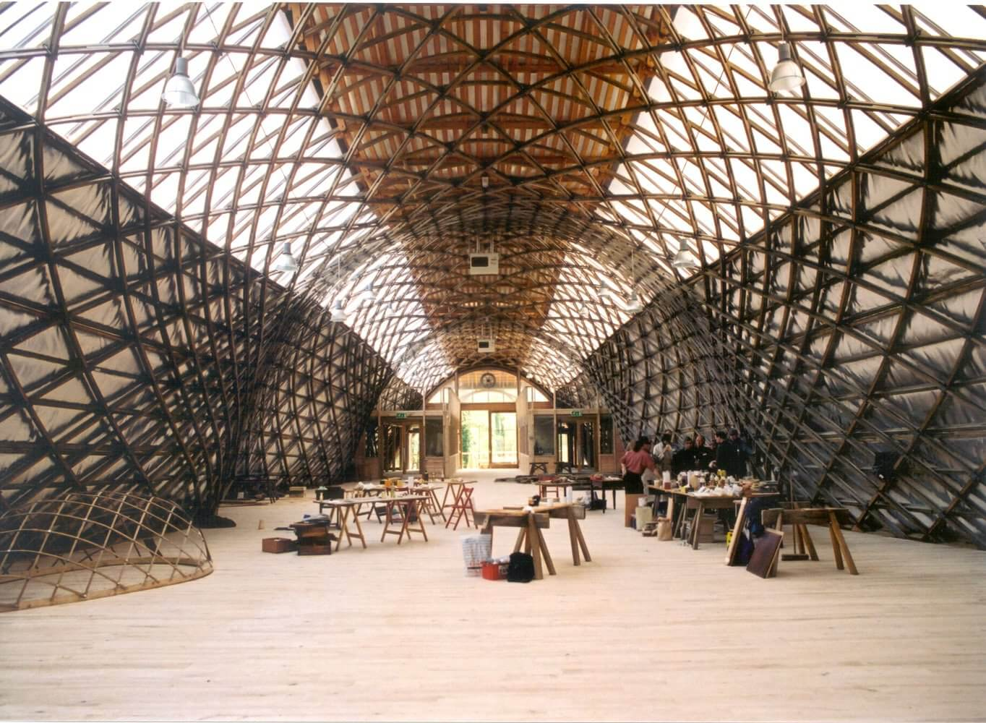  15 – 16 December 2017  Culina Artem  CONTEMPORARY ART EXHIBITION  Latin for ‘Kitchen Art’ Culina Artem is a group exhibition exploring and responding to the use, contents and social structure of the domestic kitchen as seen through the eyes of contemporary art.  Curated by BA (hons) Fine Art Students from The University for The Creative Arts.  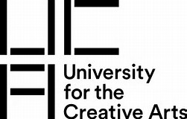 | Artists include  ────  Naty Lopez-Hoguin  Others To be confirmed  ────  ────  THE GRIDSHELL  WEALD & dOWNLAND lIVING mUSEUM  SINGLETON  cHICHESTER  WEST SUSSEX  PO18 0EU  01243 811363  wealddown.co.uk  10.30am – 4.00pm

